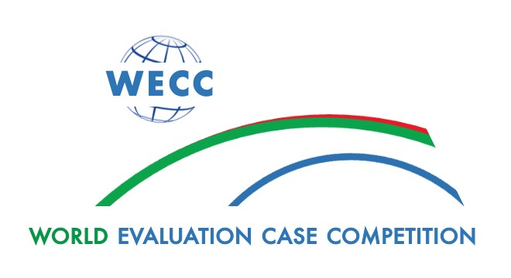

Participants in the 2023 Competition

Country & Team Name | Participant | Institution
Benin  CONSEIL-Plus  Organized by the  Afrihealth Optonet Association | BIAOU Babatounde Sergio | École Supérieure le Faucon
 | DJODDi Sika Rafatou | IFA TOSSI
 | DJENATON Isaac | FLASH Adjara
 | FATONDJI Delphin | Université Abomey Calavi
 | LALY Félicienne
Canada  Prism Consulting | Amanda Demmer | University of Waterloo
 | McKenna Szczepanowski
 | Jiselle Bakker
 | Thepikaa Varatharajan
 | Sarah Sousa
 | Coach: Jennifer Yessis
 | Coach: Kelly Skinner
Colombia  Capotera | Isabella Ricardo Hurtado | Universidad del Cauca
 | Santiago Ramirez
 | Yuliana Ante Urrea
 | Daniel Ausecha Navia
 | Jazmin Ramirez Cordoba
 | Coach: Jaime Fajardo Oliveros
Czech Republic  AUDIT GUILD Evaluation | Anezka Pokorna | Academy of Performing Arts
 | Pavel | Charles University
 | Jakub Abdallah
 | David Knapek
 | Coach: Josef Novotny
 | Coach: Viktor Kevton
Ghana  ONLY THE FAMLY  Organized by the  Afrihealth Optonet Association | Abubakar Ibrahim Umar | Bayero University Kano
 | Ikyaaga Orhiga Joseph
 | Akonsi Mohammed | University for Development Studies
 | Abdul-Rahaman Abdul Latif
 | OTTOU RENDjOGO Oswald | Public Administration GIMPA
India  The Precision Squad | Roshan R | Dr. Mahalingam College of Engineering and Technology
 | Muskaan Jamal | FLAME University
 | Akanksha Lochan Das | Meghna Desai Academy of Economics
 | Shreedutt Patnam
 | K. Nupur Temani
 | Coach: Ami Divatia | Freelance researcher
Mexico  Public Management Advisors | Juan Roberto Reynoso | Centro de Investigación en Matemáticas
 | Kevin Jhair Inzunza Ramos | Instituto Tecnológico y de Estudios Superiores de Occidente
 | Irais Hernandez
 | Sara MarÌa Baruqui
 | Ochoa Maria Josefina Mijares
 | Coach: Radamanto Portilla Tinajero
Mongolia  Progresso | Khaliunaa Batjargal | National University of Mongolia
 | Nyamsuvd Battulga
 | Enkhjin Natsagdorj | University of Finance and Economics
 | Munkh-Uchral Byambasuren
 | Nyamsuvd Battulga | National University of Mongolia
 | Coach: Uugantsetseg Gonchigdorj | Mongolian Evaluation Association
 | Coach: Ganzorig Gonchigsumlaa | Mongolian University of Life Science
Nepal  SARAS | Ahshia Sherchan | Padmakanya Multiple Campus
 | Sachin Saud | Kathmandu University School of Management
 | Rachana Bhandari | School of Management Tribhuvan University
 | Anupam Bhattarai
 | Simran Subedi
 | Coach: Govinda Tamang
Niger  Baz | Moutari Boubou Issoufou | Institut de stratégie, évaluation et de prospective
 | Amadou Soumana Samira | Université Abdou moumouni de Niamey
 | Oume Boulama Fadji
 | Djibo Kantahi Maman Siradja
 | Nouri Souley Ismaila
 | Coach: Laouali manan nassourou
Nigeria  Harice Consulting | Eric Andrew | Bayero University Kano
 | Hashimu Adamu
 | Iveren Evelyn Ayede | Benue State University, Makurdi
 | Coach: Oludotun Babyemi | Cloneshouse
 | Coach: Onochie Mokwunye
Pakistan  RIGHTS-DEV Consulting  Organized by the  Afrihealth Optonet Association | Asifa naz | Muhammad Ali Jinnah university
 | Asif ali | FUUAST
 | Arif Hassan mashori | Sindh university
 | Raza Hassan
 | Coach: Hassan mashori | FHRRDA
 | Coach: Gulnaz hassan
Uganda  YEEs-plus | Shakira Kakungulu Nachwa | Uganda Management Institute
 | Mwagale Daphine Tabitha
 | Bylon Natuha
 | ANNA ELSIE LUYIGGO | Uganda Technology and Management
 | UTHMAN ISSA KIZITO | Islamic University in Uganda
 | Coach: Vincent Ssenyondo | Uganda Management Institute
 | Coach: Eugene Swinnerstone Miheso | Makerere University
United States of America  Evalu850 | Meg Johnson | University of Massachusetts Lowell
 | Golnar Fotouhi
 | Marian Dyer
 | Nadia Sahila
 | James Fargnoli
 | Coach: Jill Hendrickson Lohmeier
ZIMBABWE  UKHOZI  Organized by the  Afrihealth Optonet Association | Soneni Moyo | Lupane State University of Zimbabwe
 | Naledi Ramushu
 | Vuyisile Ncube
 | Angelina Sibanda
 | Sukoluhle Phiri

February 7, 2024

